Legendary Enlargement EMail Swipes

Email #1:
S1: How your manhood can make you famous
S2: Why tabloids are obsessed with movie star’s junk
S3: Good looks, talent or bulge… what matters more? (You’ll be shocked)

Take a look at this guy:

<>
Recognize him?

It’s celebrity superstar Jon Hamm…

A little over a decade ago he was just another Hollywood wannabe begging for bit parts.

You might think his iconic role as Don Draper shot him to A-list fame and fortune…

But his “Hammaconda” as paparazzi have called his bulge likely played an equally big role… no pun intended ;-)

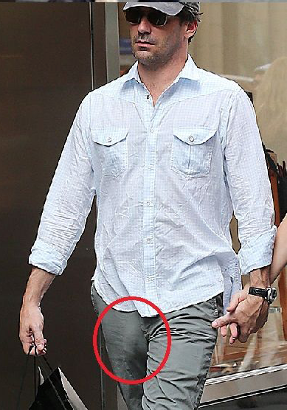
<>
That guy looks like he could have a beluga whale somewhere in his family tree...

How about Michael Fassbender?

<>
His rugged good looks, and suave British accent might get him casting calls…

But his elephant trunk flesh warrior has taken over his spotlight.

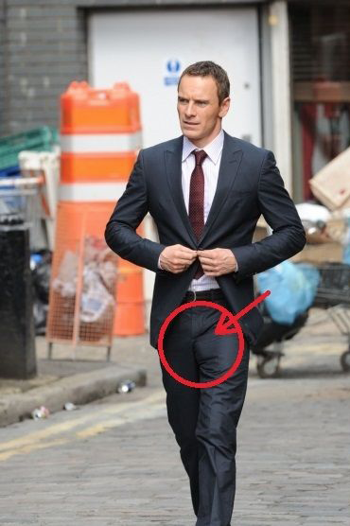
<>
And who can forget about Orlando Bloom?

<>
When Legolas was caught paddling his then girlfriend Katy Perry buck-naked…

Celebrity shutterbugs worried that his “dangling participle” might attract sharks.
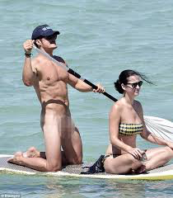
<>
So why do I mention any of this?

Well… all these celebs broke the internet, became top trends on social media and were heaped with praise from female-centered outlets like Glamour, Cosmopolitan and Vanity Fair…

So if you think “size doesn’t matter” and women aren’t impressed by a man that packs a little extra punch in his pantaloons… <https://hop.clickbank.net/?affiliate=zzzzz&vendor=legendpe>

Think again!

Women talk… they talk about S-E-X… and the buzz around a man’s bulge gets more airtime than you might think.

Now, I’m not going to tell you that you’ll become rich and famous just because you have a longer, thicker trouser python crawling down your thigh…

But I don’t think it’s hard to imagine how much better your life could get if you could hypnotize women with the sway of your powerful manhood… <https://hop.clickbank.net/?affiliate=zzzzz&vendor=legendpe>

If everywhere you went you caught sexy women staring at your crotch…

If girls blushed and whispered words of praise about your man tackle…

Now, you’re probably thinking that it’s a pipe dream…

...the size of your package is in your DNA and that after puberty there’s nothing you can do to improve it...right?

Wrong!

This girl’s boyfriend was able to add SIZE and GIRTH to his manhood in just 30 days...

>> Find Out How + See Proof <https://hop.clickbank.net/?affiliate=zzzzz&vendor=legendpe>

Signoff

Email #2:
S1: Can this nerdy engineer give you a bigger wang?
S2: Do penile extenders work?

In case you’ve been living under a rock for the last decade… you’ve probably seen ads for a “magical manhood enlarger.”

Either some kind of device, pill, or Jelqing exercise that can give you more length and girth.

So do they work?

Well that’s the question that a nerdy surgical device engineer asked after he was struggling to give his girl pleasure in the bedroom...

What he found was... despite the fact that millions of men have tried them over the past decade… the average size has not increased.

So that must mean they’re a scam right?

Well… hold on… because it’s not that simple either.

For instance…

A medical study published in the prestigious medical journal Urology showed that a condition called “megalophallus” can occur post puberty.

Basically… megalophallus means “giant penis” in Greek.

It results from an expansion of the cells of your man hammer from the inside…

All the other methods you’ve heard of rely on some magical hormone, some miracle herb, or some stretching routine which is supposed to add new tissues…

But this isn’t the way that your penis grows during puberty….
The secret to the explosive growth you experienced during puberty is due to a phenomenon called cytomechanical elongation.

>> Discover More About Cytomechanical Elongation HERE
<https://hop.clickbank.net/?affiliate=zzzzz&vendor=legendpe>

Cytomechanical elongation is a fancy term for this internal cellular expansion.
While extenders do create some tension that theoretically could lead to growth…

Most men who try then are disappointed.

And of course pumps, exercises, and pills might help you get better erections…

But they’re not going to add permanent length and girth you’re looking for.

However, the geeky engineer I was telling you about earlier discovered a simple way to turn on cytomechanical elongation in ANY man’s body…

Even if he finished growing decades ago.

Best part is… you don’t need any gadgets, pills, or ridiculous and potentially dangerous “stretching” exercises…

>> Get Permanent Post-Puberty Length + Girth <https://hop.clickbank.net/?affiliate=zzzzz&vendor=legendpe>

Signoff

Email #3:
S1: The g-spot ain’t got nothing on THIS (hit her most magical spot)
S2: Hit this magical spot and you’ll change her life
S3: Are you hitting her “magic spot”? Science says NO

Samantha thought “vaginal orgasms” were like Big Foot…

Lots of people claim they’re real… but nobody can find proof.

Her first boyfriend’s penis was more of an appetizer than a main course.

Intercourse was just a warm up event that got her turned on…
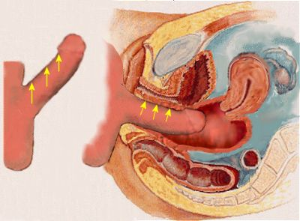
But the real fun came after he did…

He’d roll over to sleep and she’d use a pillow to finish herself.

Needless to say their relationship didn’t last.

Her next boyfriend was a popular hockey player who packed a little extra in the downstairs area…

At first… his massive manhood made her nervous… she thought it might hurt.

But when he first touched a “deep region” she’d never felt with her average-sized first lover…
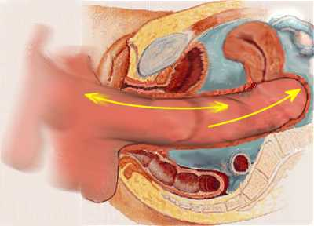
She felt a pleasant tingling that grew into an Earth shattering spasm…

She started to fantasize and crave his cock.

She even started skipping class to meet him for a couple rounds of afternoon delight…

Young Samantha had experienced the “Great Vaginal Awakening.” <https://hop.clickbank.net/?affiliate=zzzzz&vendor=legendpe>

After she caught him cheating on her she kicked him to the curb…

But she still longed for a man who could deeply touch her heart…

And whose manhood could… well… touch her deeply the way that her jerk ex-boyfriend’s did.

She met the man of her dreams… but unfortunately he had a manhood like her day job…

It did the trick and kept her out of the cold… but it didn’t create the fantasy life she dreamed of as a little girl…

But he made a strange discovery that allowed him to GROW to the challenge.

>> Find Out What He Did (Not Safe For Work)
<https://hop.clickbank.net/?affiliate=zzzzz&vendor=legendpe>

And by the way this has nothing to do with weird contraptions, surgery or Jelqing exercises that can damage your d!ck.

It’s simple, safe and scientifically proven.

Signoff

Email #4: perfect for someone who would NEVER mail for a PE offer...
S1: Can you really get bigger “down there?”
S2: “Enlargement” Fact or Fiction?

Okay so this is a controversial topic and I was really uncertain about whether or not I even really wanted to get into…

But there’s actually been a lot more curiosity around this issue than I expected.

So I decided I’d throw caution to the wind and at least touch on it.

I was recently talking to my friend Olivier at Juicing For Your Manhood (JFYM team) the other day. He’s an expert on nutrition and hormone balancing for men.

He recently started collaborating with one of those guys who teaches men how to “get bigger down there…”

Now, this is a little bit embarrassing for me to talk about… but like I said, I was literally SHOCKED at how much interest there was in the topic.

Normally, I would almost certainly blow this off as BS… but Olivier is a guy I respect.

He basis everything he does on solid research, scientific literature, and personal experience…

So I was willing to hear him out.

Now, if you want to check out the program CLICK HERE…
<https://hop.clickbank.net/?affiliate=ZZZZZZ&vendor=legendpe>
But be warned... this is definitely graphic/not safe for work and I’m not endorsing anything here.

I still am not completely convinced that there’s anything to this stuff, but the guy that Olivier is talking about has a big Reddit following, seems scientifically literate, and has over 2 decades worth of experience.

Now, I still cannot vouch for whether this works but I can vouch for the fact that Olivier is a guy with integrity who operates an ethical business.

So go ahead and take a peak at what I’m talking about here:

>> Get Bigger Down There? (Not Safe For Work)
<https://hop.clickbank.net/?affiliate=ZZZZZZ&vendor=legendpe>

Your Signoff

